The Academic Resource Center is very important to UB, as it provides global support to students, providing tutoring services, and helps with all aspects of academic and professional life. However, the main feature of this organization is its tutoring service, and it is here that we found the most potential for improvement. The ARC uses a pen and paper system, which documents appointments, or tutoring sessions, shared by students and tutors. This paper document is of tremendous importance, as it is the evidence for tutoring hours, which are then billed as the support for the ARC.
The ARC gets its support from third parties, which provide the money for the tutors and accurately allocate the funds to the proper places, or programs within the ARC.
The database that we’ve created adds additional business value in many ways, and essentially aims to streamline the ARC’s operations, freeing up time and personnel. The database digitizes the whole process, allowing easier communication between the ARC and the third parties, longer and safer storage (which will take up a lot less room), and saving a lot of time that can then be used for other business activities, or even eliminating superfluous positions within the organization. The database connect students and tutors via “appointments”, which are events that describe a single tutoring session. Each appointment has a report, and these would be stored where they could quantify the number of tutoring hours. These would also draw from tables full of information on both the students and the tutors, saving time when tutoring (with the current system, each form contains redundant information such as student name, tutor name, class, etc. that would not need to be filled out over and over in the new system).
An enhancement to our database that would maximize its overall business value is the ability to ensure legitimacy and avoid misappropriation of funds from the third parties that fund the Academic Resource Center. Based on the current structure of the database, the amount of hours logged in by tutors can be forged with very little effort; a problem also found in the Academic Resource Centers Paper and Pen System that currently exists. Although no specific plans are in place to create this feature, one very basic option available to facilitate this involves the use of Student ID cards and swipers. Student ID cards are unique to one student and would ensure further legitimacy since they cannot be duplicated. Also, it is through these cards that students gain access to many other resources on campus; therefore, the possibility of a student lending out an ID card to a tutor with the intention of forging hours is reduced drastically since they require the use of their cards throughout their normal day-to-day routine on campus.
For our backup, we will make sure the data in the Access is sent to Excel spreadsheet on a daily basis. That would create another file in different format with all the data that would be sent to third party. Which gives the Arc center reassurance that the documents are safe. That would be the best approach because we are not using pen and paper system and Excel is a reliable source. In addition, we could create a Network Drive for the ARC center, where all the Access and Excel documents will be saved. This can all be done with the simple requirement that tutors save the information logged into an excel spreadsheet at the end of each day. The basic instructions to save this information onto a spreadsheet are as follows:
- Navigate and open the Appointment table
- Click the External Data ribbon
- Click on Export to Excel Spreadsheet icon
- Under ‘specify export options’ click Export data with formatting and layout and Open the destination file after the export operation is complete
- Save file in Microsoft Excel with current day’s date

MGS351 A11 Group 3
Final Project Report
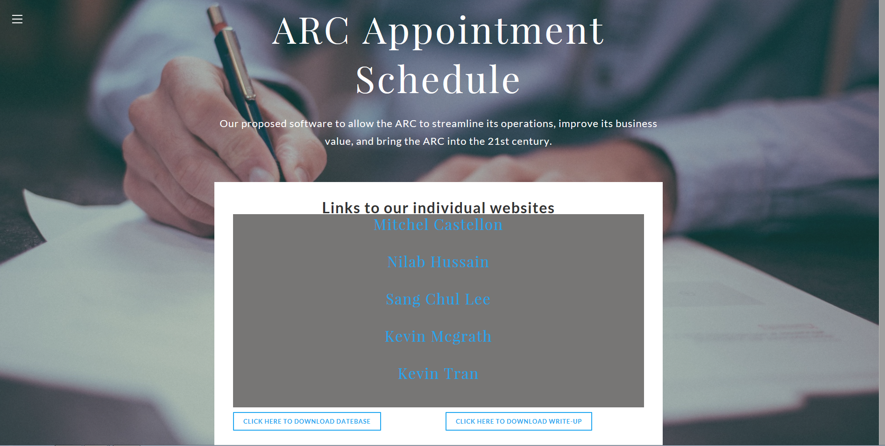

http://mgs351a11group3.weebly.com/

Kevin Mcgrath
Kevin Tran
Mitchel Castellon
Nilab Hussain
Sang Chul Lee

